HOMEWORK

--1)List the following details of each employee: employee number, last name, first name, gender, and salary.

SELECT employees.emp_no, employees.last_name, employees.first_name, employees.gender,salaries.salary

FROM employees, salaries

WHERE employees.emp_no = salaries.emp_no;

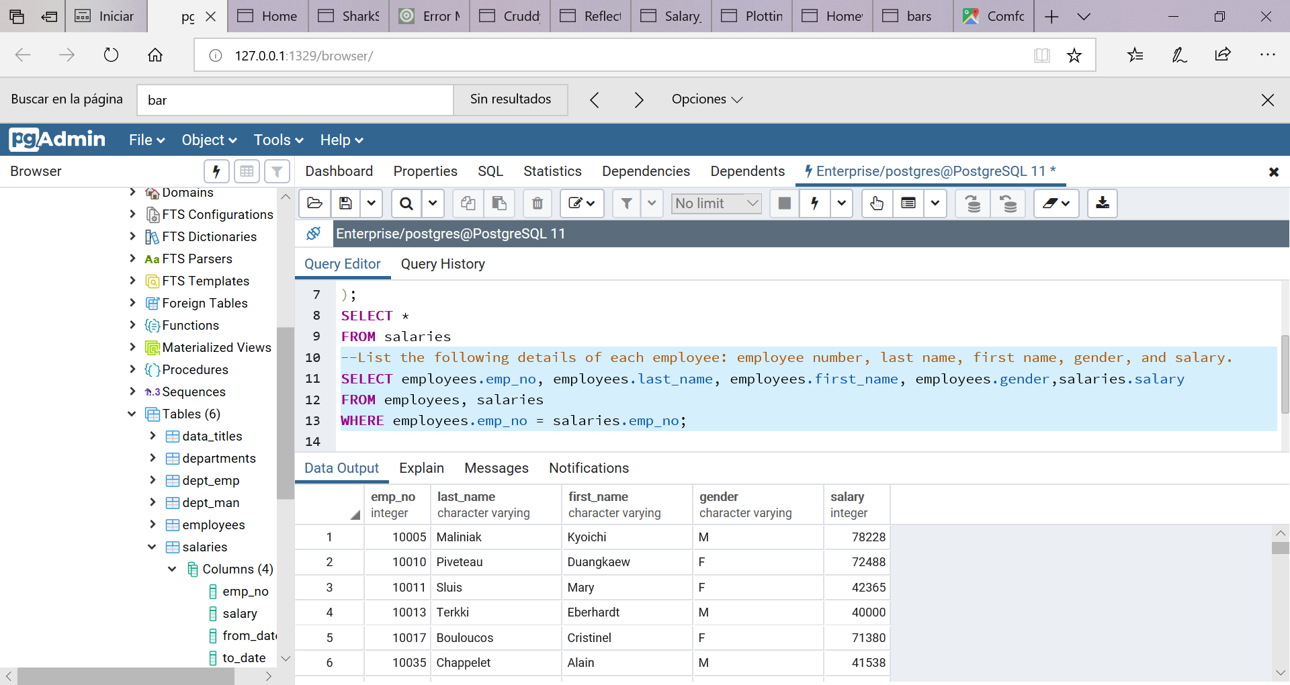

--2.-List employees who were hired in 1986.

SELECT emp_no,last_name,first_name,hire_date

FROM employees

WHERE hire_date BETWEEN '1986-01-01' AND '1986-12-31';

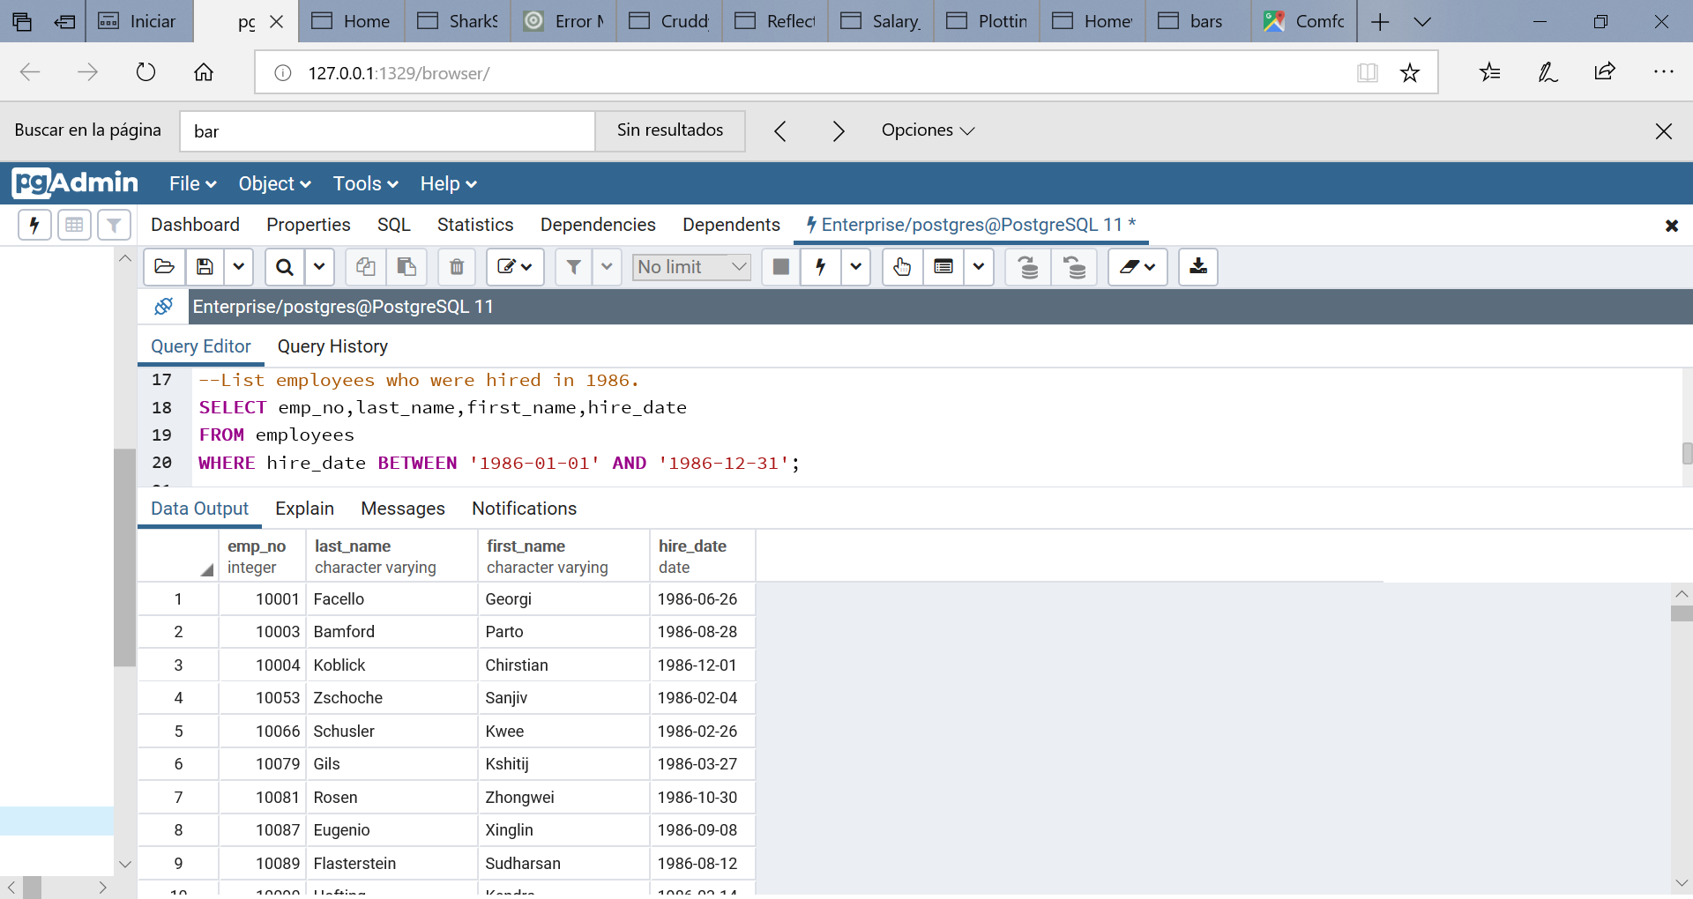

3.- List the manager of each department with the following information: department number, department name, the manager's employee number, last name, first name, and start and end employment dates.

SELECT departments.dept_no, departments.dept_name, dept_man.emp_no, employees.last_name, employees.first_name, dept_man.from_date, dept_man.to_date

FROM departments

JOIN dept_man

ON departments.dept_no = dept_man.dept_no

JOIN employees

ON dept_man.emp_no = employees.emp_no;

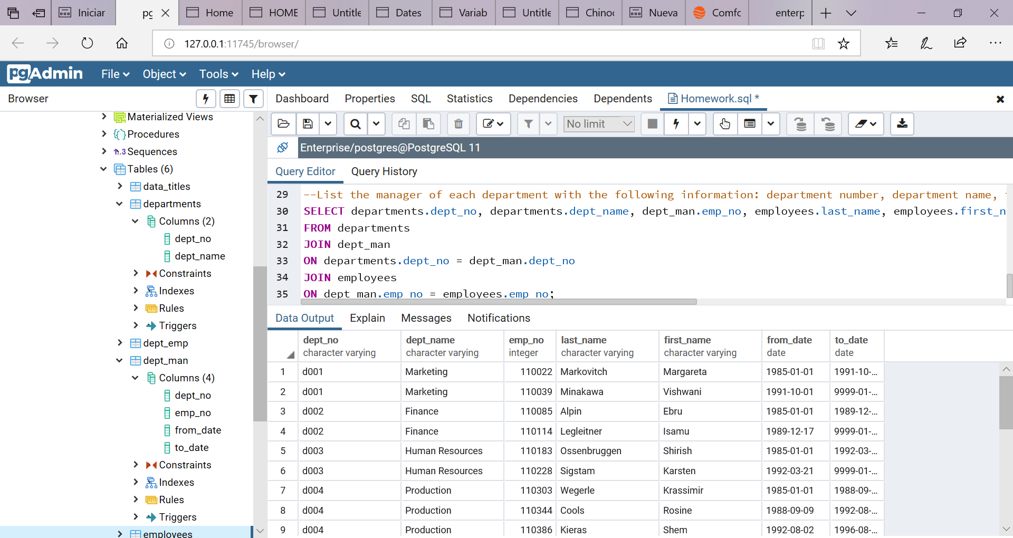

--4.-SELECT dept_emp.emp_no, employees.last_name, employees.first_name, departments.dept_name

FROM dept_emp

JOIN employees

ON dept_emp.emp_no = employees.emp_no

JOIN departments

ON dept_emp.dept_no = departments.dept_no;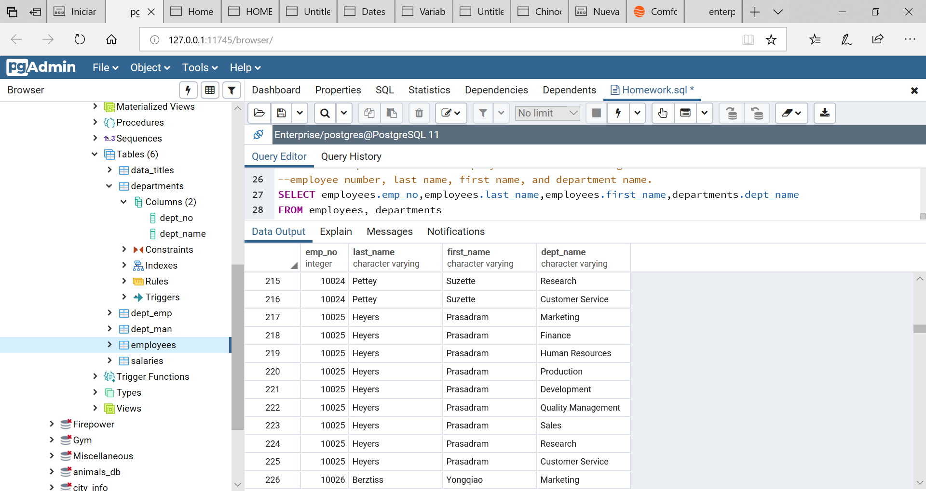

5.-SELECT first_name,last_name

FROM employees

WHERE first_name ='Hercules' AND last_name LIKE 'B%';

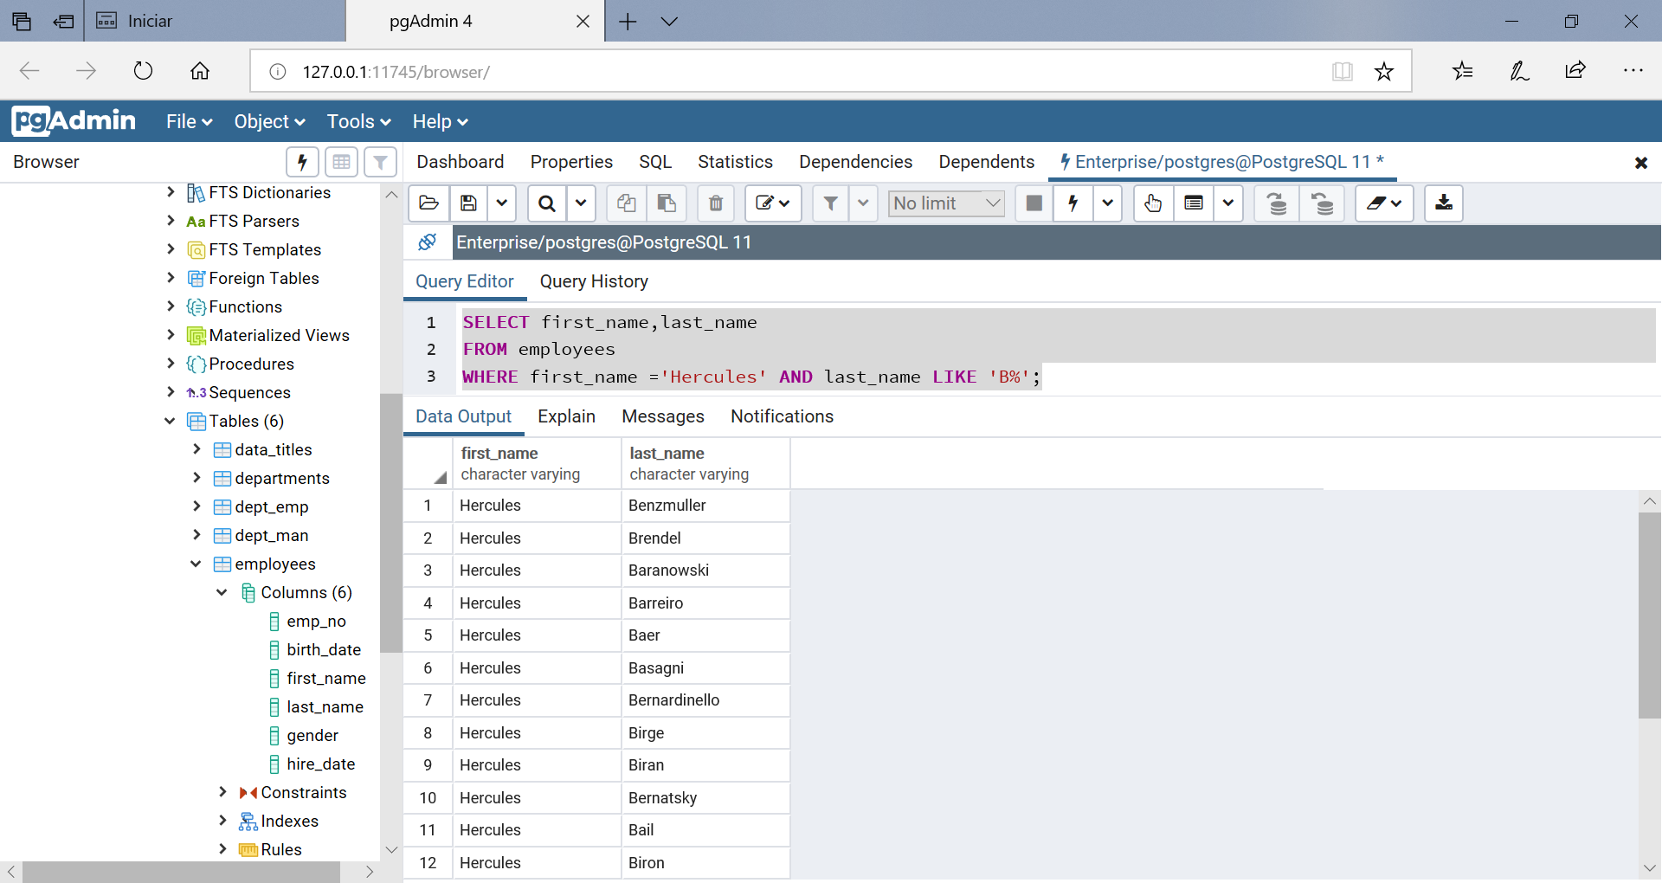

--6.-List all employees in the Sales department, including their employee number,

--last name, first name, and department name.

SELECT employees.emp_no, employees.last_name, employees.first_name,departments.dept_name

FROM employees, departments

WHERE dept_name='Sales';

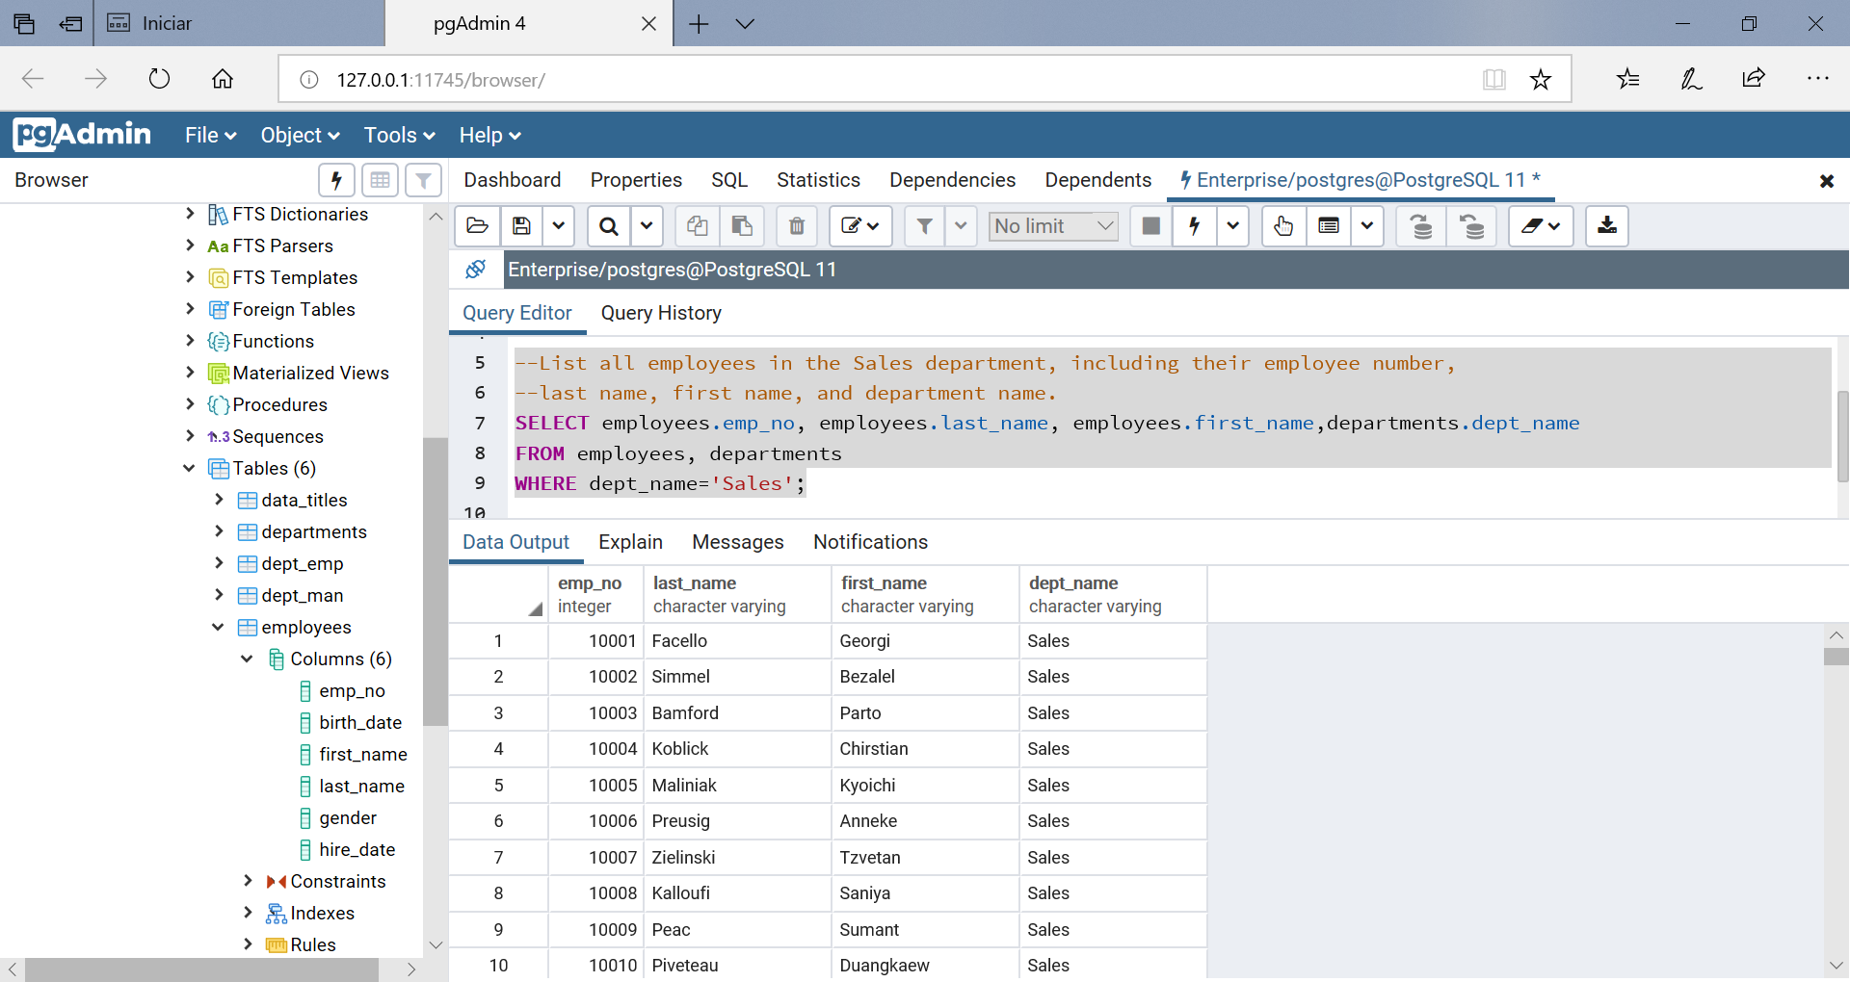

--7.-List all employees in the Sales and Development departments, including their employee number,

--last name, first name, and department name.

SELECT employees.emp_no, employees.last_name, employees.first_name,departments.dept_name

FROM employees, departments

WHERE dept_name='Sales' OR dept_name='Development';

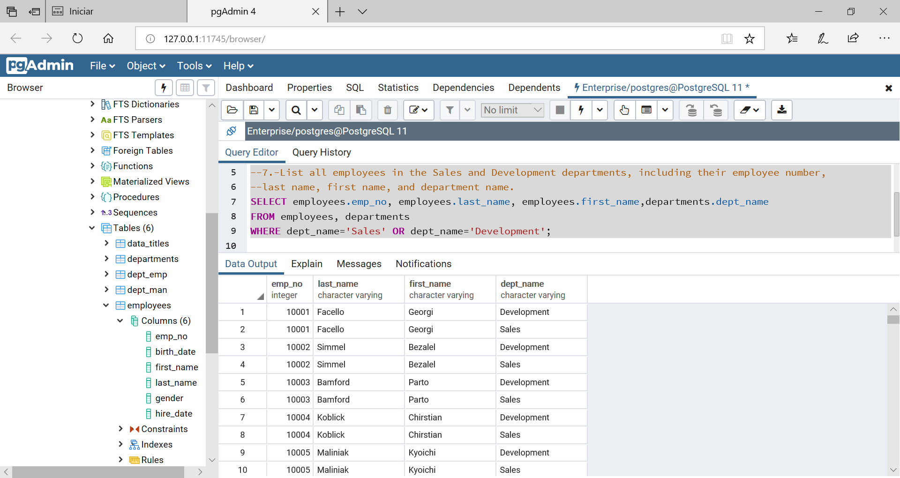

--8.-In descending order, list the frequency count of employee last names,

--i.e., how many employees share each last name.

SELECT COUNT(last_name),last_name

FROM employees

GROUP BY last_name

ORDER BY COUNT(last_name) DESC;

